**Types of Cloud**

* There are 3 popular types of cloud
  + Public Cloud:
    - This caters to majority of cloud usage, where the infrastructure is owned by CSP and Consumers use the cloud by utilizing services
    - Example:
      * Amazon Web Services
      * Azure
      * Google Cloud Platform
  + Private Cloud
    - This represents the infrastructure maintained by organization which caters to the same organization by providing services
    - Examples: OpenStack
  + Community Cloud:
    - This cloud is generally public but caters to a certain community
    - Examples:
      * Government Cloud
      * HealthCare Cloud
* Hybrid Cloud: This is combination of on-premises and cloud  
  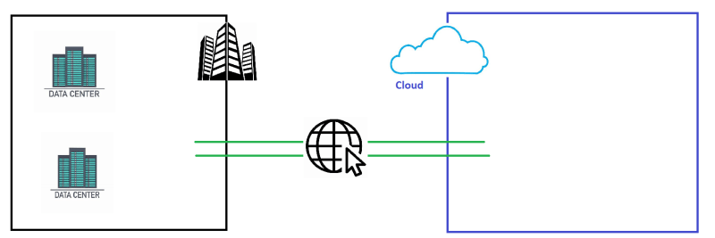

**Login to the Linux Instance**

* Overview  
  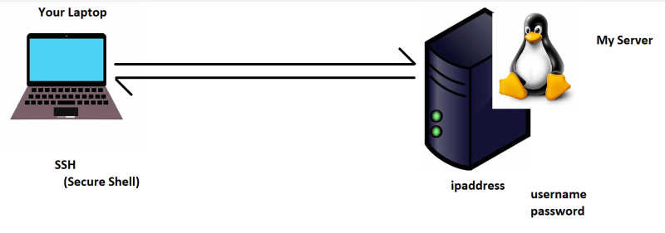
* The ssh command is ssh username@ipaddress  
  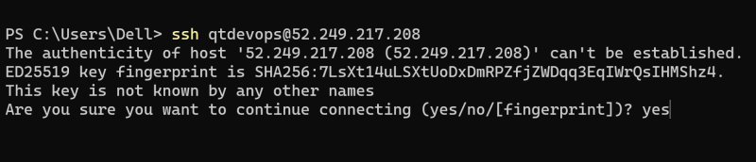  
  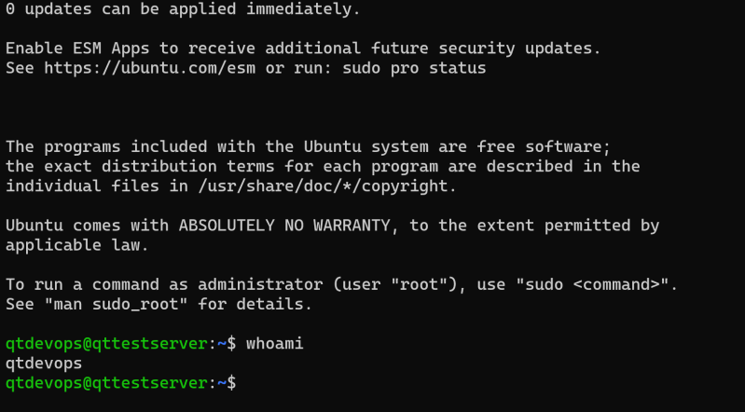
* To exit out of session use exit command

**What is Command**

* A command is an instruction which you pass to os. To run commands, we need terminal.
* Command will have the following syntax  
  command [arguments]
* Lets look at one command

ipconfig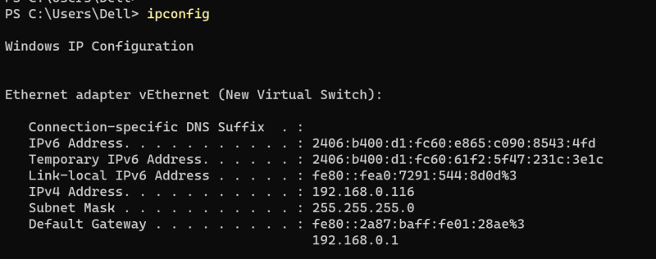

ping google.com

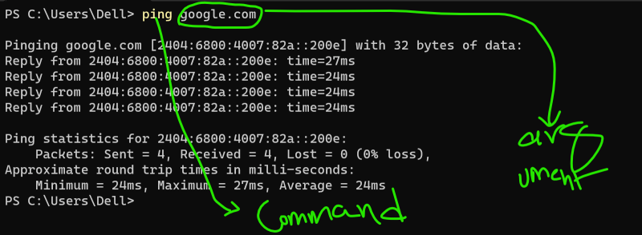  
Note: while using commands be cautious about spaces and cases (upper case and lower case)